**PYTHON PROJECT**

**College and Clubs**

There are two clubs operating in your college. The first one is a dance club named as ‘Extravenza’ and the other is a sport club named as ‘Tez’. Some of the students are enrolled in Extravenza, some of them are enrolled in Tez. But there is a small group of students who are enrolled in both of these clubs.

You as a representative of the student council is given a task to tell the total count of students who are enrolled in at least one of the clubs.

**Code:-**

**A=[]**

**B=[]**

**L1=input("Students in Club Extravenza: ")**

**L2=input("Students in Club Tez: ")**

**L3= L1+L2**

**for i in L3:**

**if i not in A:**

**A.append(i)**

**else:**

**B.append(i)**

**print("Students in both the Clubs: ",B)**

**print("No. of Students who are enrolled in atleast one of the clubs:",len(A))**

**OUTPUT:-**

**Students in club Extravenza: 123456**

**Students in club Tez: 23189**

**23189**

**Students in both the clubs: [‘2’,’3’,’1’]**

**No. of students who are enrolled in atleast one of the clubs: 8**

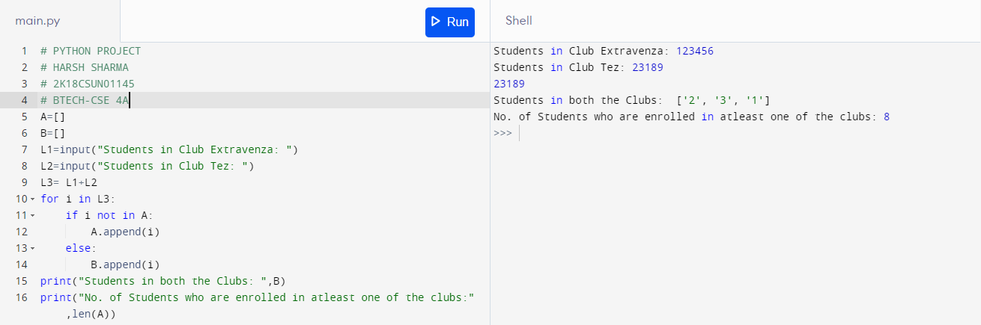

|  |  |
| --- | --- |
| **HARSH SHARMA** | **2K18CSUN01145** |
| **Btech-CSE** | **4A** |